OS LAB 1
Laiba Fatima
22k-5195

Q1.

• apt-get
for handling packages, and may be considered the user's "back-end" to other tools using the APT library.

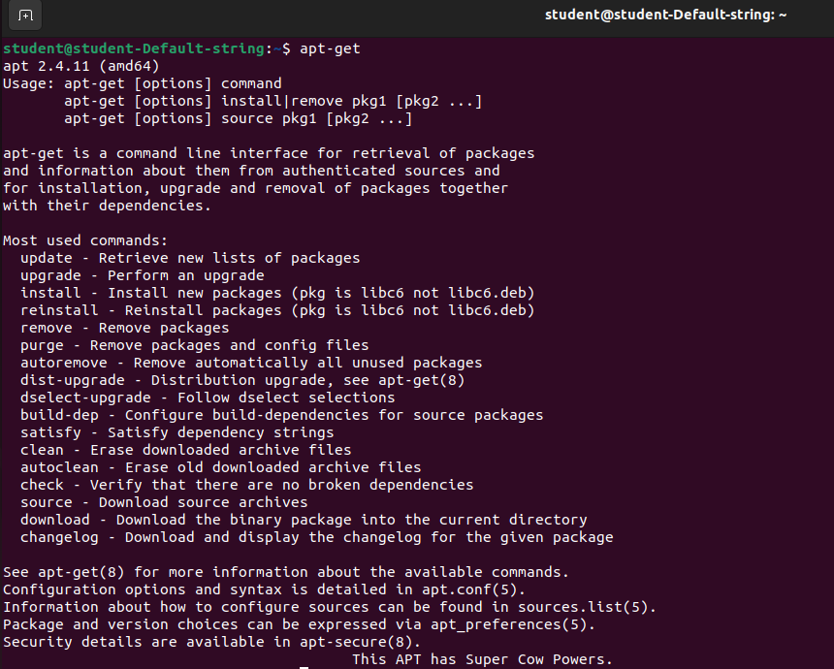

• yum
It can automatically perform system updates, including dependency analysis and obsolete processing based on repository metadata.
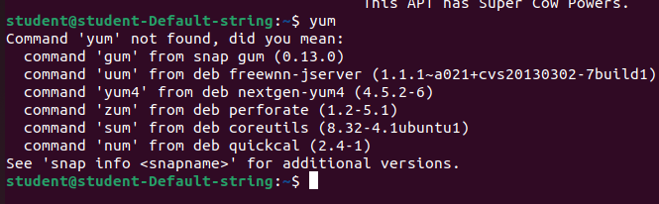
• wget
it retrieves content from web servers by writing the link with this command

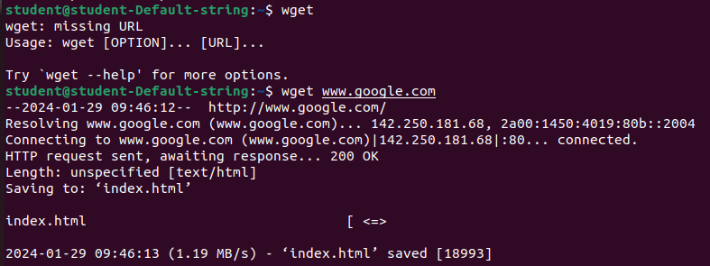

• gzip

Each single file is compressed

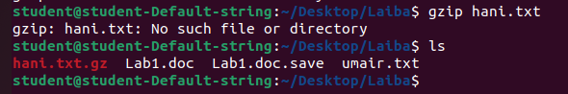
• tar
It compress a group of files into an archive

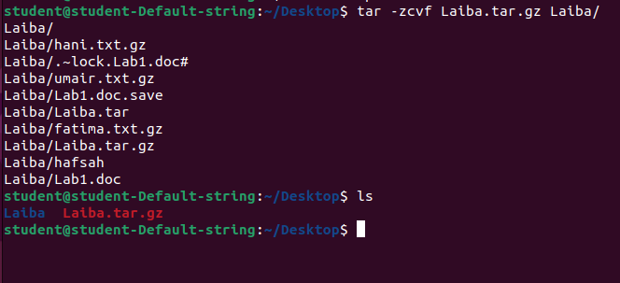
• rar
It extracts rar files

Q2.

• show architecture of machine

arch: X86_64

• show CPU info

lscpu

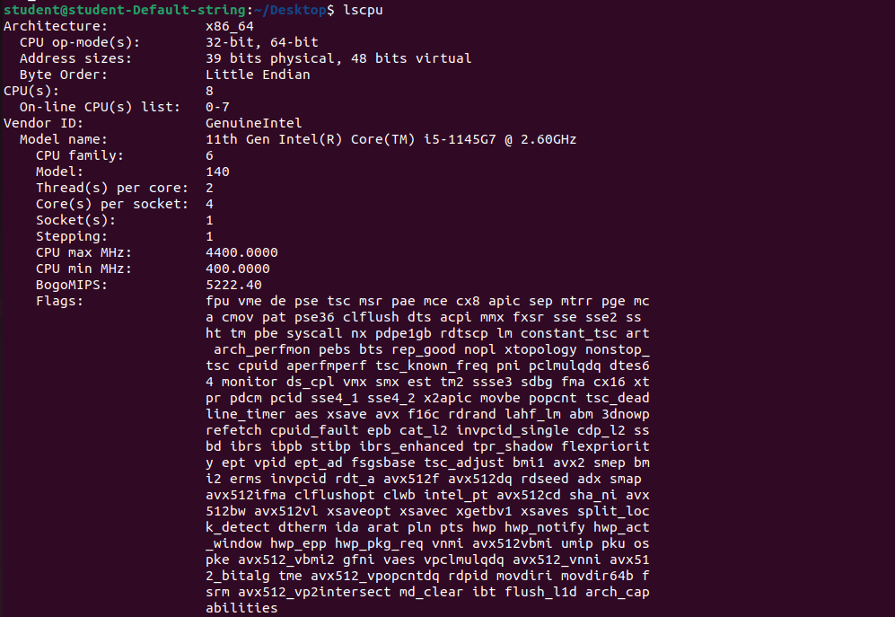
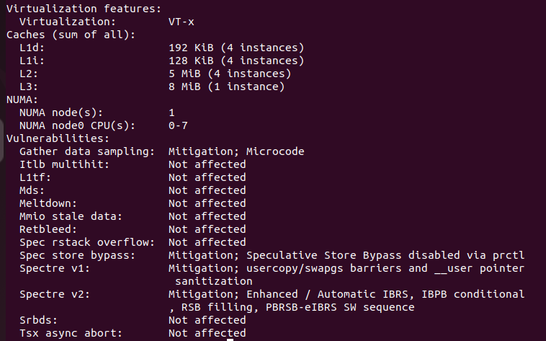
• show version of the kernel

uname -r

• show system date

date

• set date and time

date -s

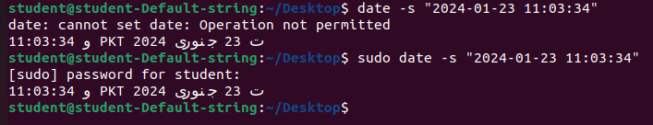

• show details of files and directory

ls

• show hidden files

ls -ld .?*
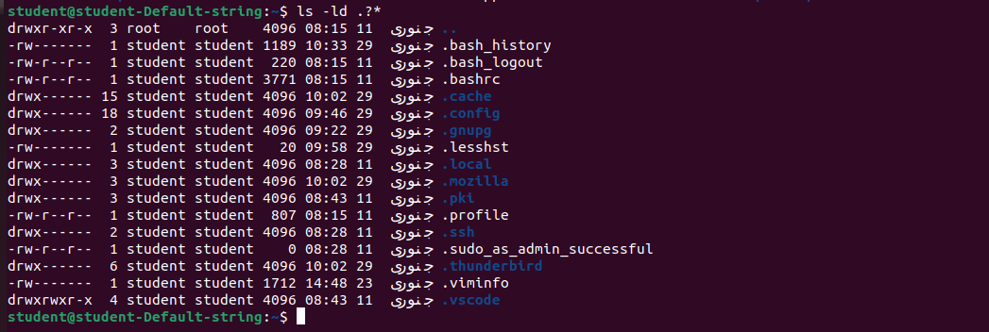

• show files and directory containing numbers

ls [0-9]

• create a directory called ‘dir1’

mkdir

• create two directories simultaneously

mkdir dir1 dir2

• show the path of work directory

pwd

• delete file called ‘file1’

rm

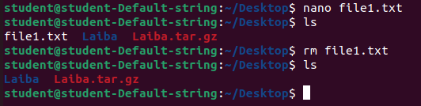

• remove a directory called ‘dir1’ and contents recursively

rm -r

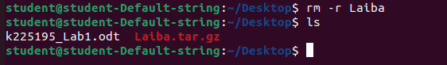

• delete directory called ‘dir1’

rmdir

• modify timestamp of a file or directory

touch myfile.txt
ls -l
